**Championing LGBTQ+ support and mental wellbeing through the staff 'Check in with Pride' campaign**

**1. Briefing note**

**Check-in with Pride** aims to foster a more inclusive and compassionate workplace environment, and better support our LGBTQ+ colleagues by encouraging open conversations and providing tailored resources. We ask communications teams and organisations to join West Yorkshire Health and Care Partnership in actively promoting this campaign, directing staff to ‘[StaffCheck-in.co.uk/pride](http://staffcheck-in.co.uk/pride)’ for dedicated LGBTQ+ mental wellbeing support.

Why?

Issues such as discrimination, homophobia and transphobia, plus experiences of hate, social isolation and rejection mean that LGBTQ+ people can unfairly experience more mental health challenges. (See section 5 for evidence on these challenges).

How you can get involved:

Use your communication channels to share the news item in this pack, promote the social media posts on LGBTQ+ awareness days, and ensure all staff have access to these vital resources.

When?

Please promote this campaign from World Suicide Prevention Day on **10 September 2024, across the month of September and beyond** to encourage greater awareness and access to support .

_

**2. News item**

Release Date: Please publish the news item below through your organisation’s news and communications channels starting on World Suicide Prevention Day - 10 September 2024 - and continue sharing it beyond, to ensure that the message of mental wellbeing and support reaches staff throughout the year.

Championing LGBTQ+ support and mental wellbeing through the staff 'Check in with Pride' campaign

As part of our ongoing commitment to staff wellbeing, we are proud to relaunch the 'Staff Check-In' campaign, which has been revised to include a dedicated LGBTQ+ section ‘Check-In With Pride’ [StaffCheck-in.co.uk/pride](http://staffcheck-in.co.uk/pride).

The relaunch coincides with World Suicide Prevention Day, on 10th Septmber 2024, and encourages everyone to make ‘checking in’ with colleagues a regular part of our work culture.

With the addition of ‘Check In with Pride’ the campaign aims to highlight the inequalities and unique mental wellbeing challenges LGBTQ+ staff may face. As well as providing signposting to targeted support, communication assets and suicide prevention training, ensuring staff of all identities feel supported.

How to get involved:

* Be a LGBTQ+ ally. Check out [StaffCheck-in.co.uk/pride](http://staffcheck-in.co.uk/pride) to learn more about the unique mental wellbeing challenges LGBTQ+ people face and share some of the communication assets with pride.
* Tailored mental wellbeing support resources: the [staffcheck-in.co.uk](http://staffcheck-in.co.uk) homepage includes a resource and support section with handy filters to help you find the right support for you or someone else.
* Check-in with colleagues: A simple conversation can go a long way in supporting each other’s mental wellbeing. Let's make our workplaces a space where open, compassionate communication is the norm.

Accessing support:  
[Note: You can use this space to insert specific information about your organisation’s Wellbeing champions, leads, or staff networks here.]

Let’s make a collective effort to check in with each other, supporting mental wellbeing one conversation at a time.

_

END

**3. Promote your news item**

Promote your news item on World Suicide Prevention Day (10 September 2024) using social media content like the examples shown below:

News item social post 1:

Our mission is to create a workplace where mental wellbeing conversations are encouraged, normalised, and inclusive of everyone. Join us in making a difference by accessing vital resources and participating in regular check-ins with your colleagues. Let’s work together to build a workplace where all staff feel supported and valued.

Read all about it here: [INSERT YOUR ARTICLE URL] and visit [StaffCheck-in.co.uk/pride](http://staffcheck-in.co.uk/pride) to learn more and get involved.

#StaffCheckIn #MentalWellbeing #SupportEachOther #LGBTQSupport #WorldSuicidePreventionDay #WestYorkshire

**4. Awareness days social posts for LGBTQ+ colleagues**

Please note: Social media images for each of the awareness day posts below can be downloaded at [StaffCheck-in.co.uk/pride](http://staffcheck-in.co.uk/pride), listed as ‘Awareness days social posts’ in the Campaign Resources area at the bottom of the web page.

February: LGBT History Month begins (UK-wide)

As LGBT History Month starts, let's remember the importance of positive mental wellbeing within the LGBTQ+ community. 🌈 By celebrating history, we empower ourselves and others. Let's create a supportive environment where everyone's mental health is valued. Visit [StaffCheck-in.co.uk/pride](http://staffcheck-in.co.uk/pride) to access resources for promoting mental wellbeing. #LGBTHistoryMonth #MentalHealthMatters #WestYorkshire

April: Lesbian Visibility Week

This #LesbianVisibilityWeek, let's celebrate our diverse voices and prioritise mental wellbeing.🌈 💬🧠 Sharing our stories and experiences can break down barriers and create a more supportive workplace. Reach out, connect, and let’s keep the conversation going. Visit [StaffCheck-in.co.uk/pride](http://staffcheck-in.co.uk/pride) #MentalWellbeing #WestYorkshire

May: International Day Against Homophobia, Biphobia, and Transphobia (IDAHOBIT)

On International Day Against Homophobia, Biphobia, and Transphobia let's reaffirm our commitment to creating a world where everyone can thrive mentally and emotionally, free from discrimination. 🏳️‍🌈 Together, we can combat stigma and promote positive mental health for all. Visit [StaffCheck-in.co.uk/pride](http://staffcheck-in.co.uk/pride) #IDAHOBIT #MentalWellbeing #Yorkshire

June - August: Pride events across different cities in the UK

Pride is a time of joy and empowerment, but it's also an opportunity to advocate for mental wellness within the LGBTQ+ community. 🎉 Let's come together to support each other's mental health journeys and break down barriers to accessing support. Visit [StaffCheck-in.co.uk/pride](http://staffcheck-in.co.uk/pride) to find resources for nurturing positive mental wellbeing. #Pride #MentalHealthSupport #Yorkshire

Let’s break the stigma of talking about mental health for everyone. Visit [StaffCheck-in.co.uk/pride](http://staffcheck-in.co.uk/pride) to find out more and how you can support your LGBTQ+ friends, family, neighbours, work mates and chosen family.

Together we can normalise mental health conversations, and make sure everyone is included 🏳️‍🌈. Find out how you can Check-in with Pride at [StaffCheck-in.co.uk/pride](http://staffcheck-in.co.uk/pride).

July: UK Black Pride

UK #BlackPride is a time to celebrate and promote positive mental wellbeing. 🏳️‍🌈💬 Let's support each other by sharing our stories and lifting each other up. Your mental health matters! Together, we thrive. Visit [StaffCheck-in.co.uk/pride](http://staffcheck-in.co.uk/pride) for support services and resources. #MentalWellbeing #BlackLGBTQ+ #WestYorkshire

November: Transgender Day of Remembrance (TDOR)

This Transgender Day of Remembrance, we prioritise the mental wellbeing of our trans community. 💬🏳️‍⚧️ Let's create safe spaces for conversations, support each other, and remember: your voice matters, your mental health matters. Visit [StaffCheck-in.co.uk/pride](http://staffcheck-in.co.uk/pride) for support services and resources. #TDOR #TransRights #MentalWellbeing #WestYorkshire 💙💗🤍

November: Transgender Awareness Week

Transgender Awareness Week is a time to uplift trans voices and advocate for mental wellness within the transgender community. 🌟 Let's foster understanding, acceptance, and access to mental health resources. Together, we can create a world where everyone can thrive mentally and emotionally. Visit [StaffCheck-in.co.uk/pride](http://staffcheck-in.co.uk/pride) to learn more. #TransAwarenessWeek #MentalWellbeing

**5. Insights to inform support for LGBTQ+ colleagues**

National evidence, and knowledge from research across West Yorkshire, suggests LGBTQ+ people are at greater risk of poor mental wellbeing therefore Check-In includes tailored support. Here is some more information for your organisation:

LGBTQ+ staff are more likely to experience conflict and harassment at work

A [report](https://www.cipd.co.uk/knowledge/fundamentals/relations/diversity/inclusion-perspectives-lgbt) by the CIPD revealed LGBTQ+ staff are more likely to experience conflict and harassment at work than their heterosexual and cisgender colleagues. Furthermore the [2023 NHS Staff Survey](https://nhssurveys.co.uk/nss/questions/national) found that 32% of gay or lesbian staff and 35% of transgender staff reported bullying and harassment at work. Around one in five LGBTQ+ NHS staff reported personally experiencing physical violence at work. This infographic from the Health and Care LGBTQ+ Leaders Network [explores the growing LGBTQ+ staff experience gap and](https://www.nhsconfed.org/articles/exploring-lgbtq-staff-experience-nhs) actions you can take to support LGBTQ+ NHS colleagues.

2022 YouGov: LGBT+ Britons more likely to report suffering with mental health conditions

“LGBT+ Britons are more likely to suffer with mental health conditions such as anxiety, depression and insomnia, a new YouGov survey shows. Over the last 12 months, half of LGBT+ Britons (51%) say they experienced or were diagnosed with a mental health condition, compared to a third of the general population (32%).”

[Source](https://yougov.co.uk/society/articles/43010-lgbtbritons-more-likely-report-suffering-mental-h)

2022: Gender-related self-reported mental health inequalities in primary care in England: a cross sectional analysis using the GP Patient Survey

This study shows large gender-related inequalities in self-reported mental health outcomes in England. Given the existence of self-reported unmet mental health needs, it suggests that better health care system inclusivity and health-care professional training are needed, alongside broader improvements in the social and legal environment for transgender, non-binary, and gender diverse people.

[Source](https://www.thelancet.com/journals/lanpub/article/PIIS2468-2667(23)00301-8/fulltext)

Mental health in people with minority sexual orientations: A meta-analysis of population-based studies: Wittgens et al. (2022). *Academic meta-analysis (a very robust approach in research):*

“Integrating the findings of population-based studies conducted over the last 20 years, this meta-analysis found an overall higher risk for mental disorders in sexual minority people compared with heterosexuals. Both lesbian/gay and bisexual people had a higher risk for all examined diagnostic categories than heterosexual people. When comparing bisexual people to lesbian/gay people, bisexual people had a higher risk for depression and suicidality.”

[Source](https://onlinelibrary.wiley.com/doi/full/10.1111/acps.13405)

**6. Signposting to information and support for LGBTQ+ colleagues**

The staff ‘Check-in’ website ([StaffCheck-In.co.uk](http://staffcheck-in.co.uk)) has now been updated to include more services tailored to LGBTQ+ support.

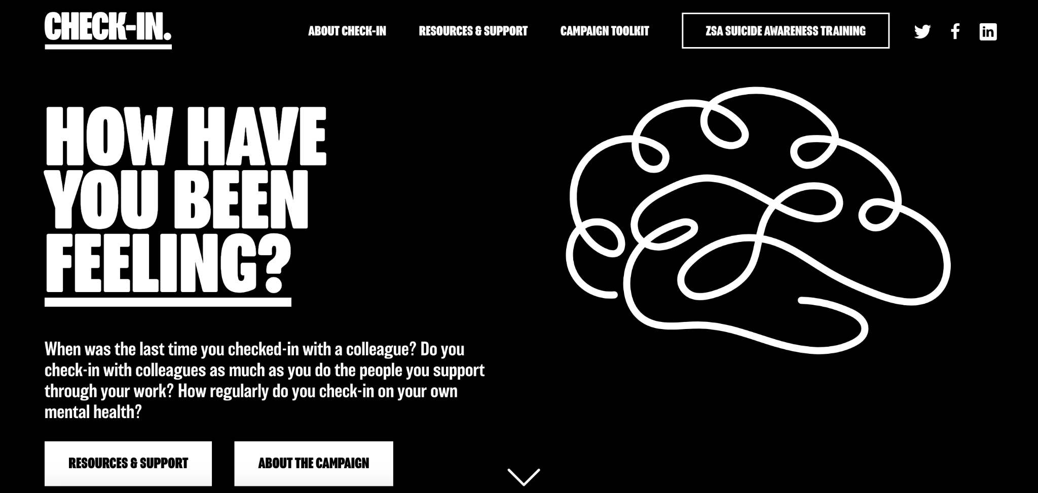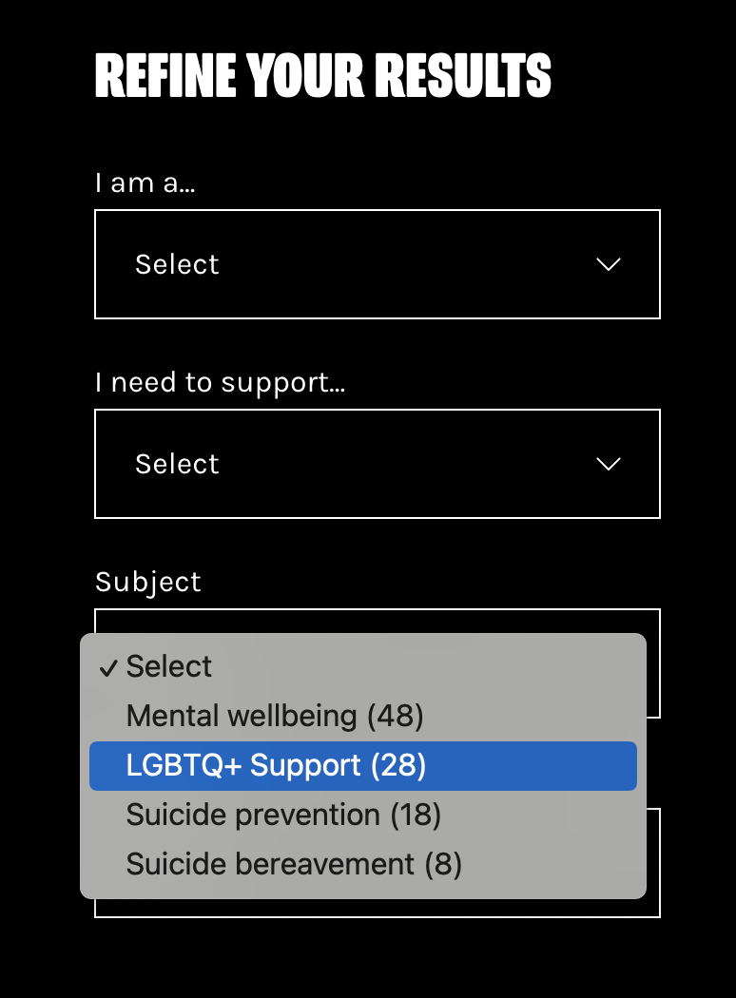

The main navigation now points to the ‘Check-in with Pride’ page ([StaffCheck-in.co.uk/pride](http://staffcheck-in.co.uk/pride)) which offers local and national LGBTQ+ support services and campaign assets.

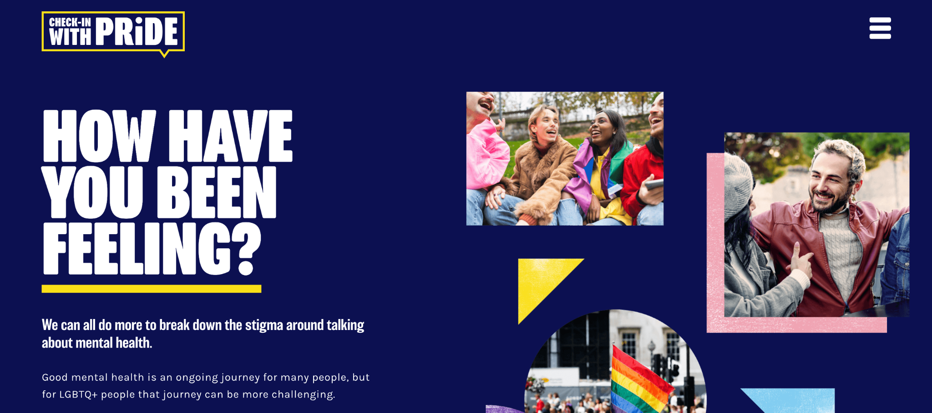

The resources area of the StaffCheck-In.co.uk homepage now signposts to tailored support for our LGBTQ+ colleagues:

